Walkthrough 26 Remote OData Service

https://sapui5.hana.ondemand.com/#/topic/44062441f3bd4c67a4f665ae362d1109



Core Changed Codes Compared to Last Version:

1.对于本地WebIDE不生效,仅对云版本WebIDE生效

manifest.json 增加数据源并分配给model:invoice

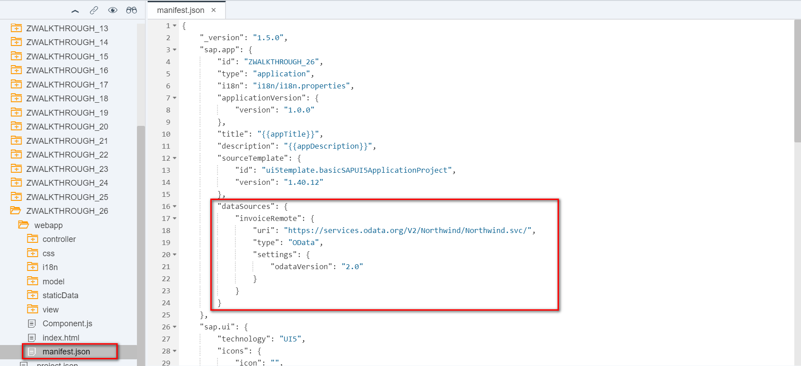

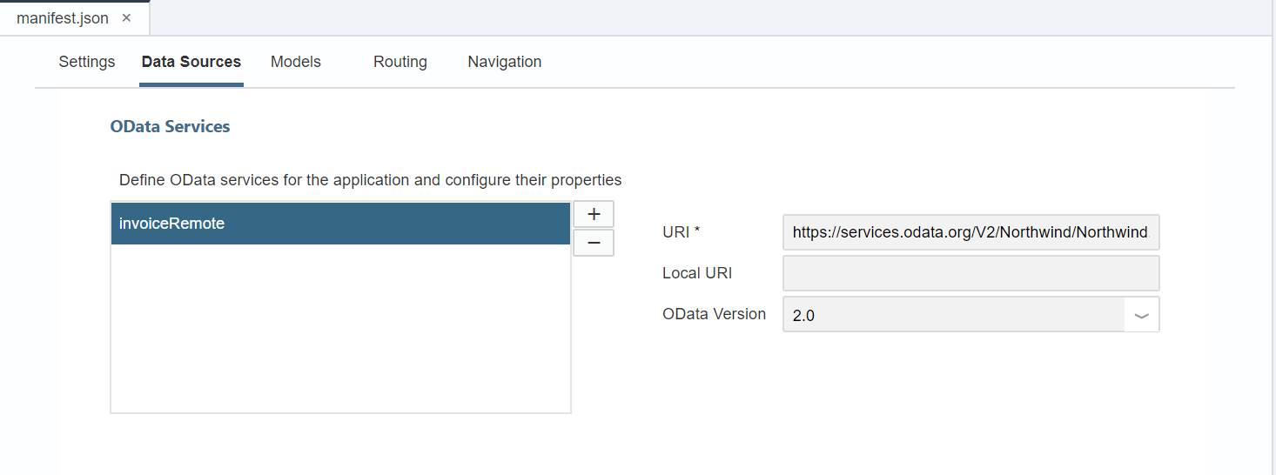

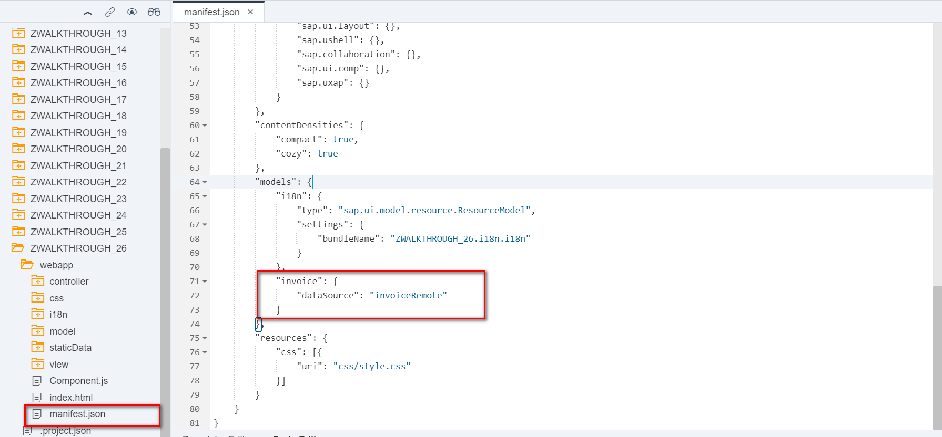

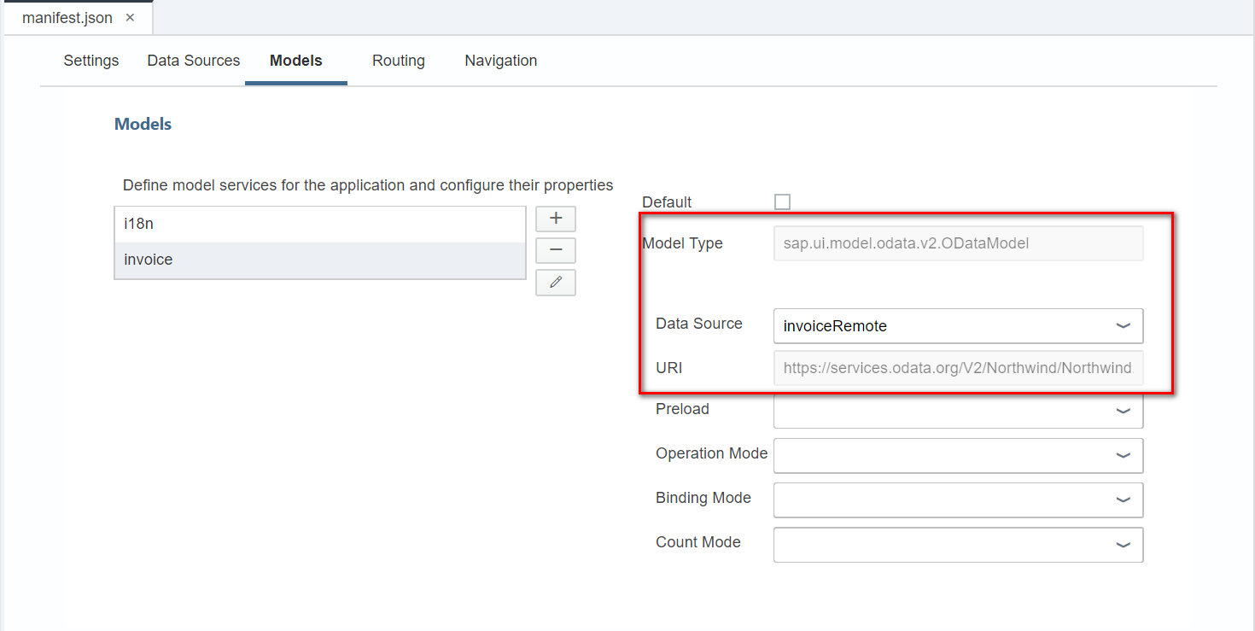

SAP Cloud Platform Cockpit配置

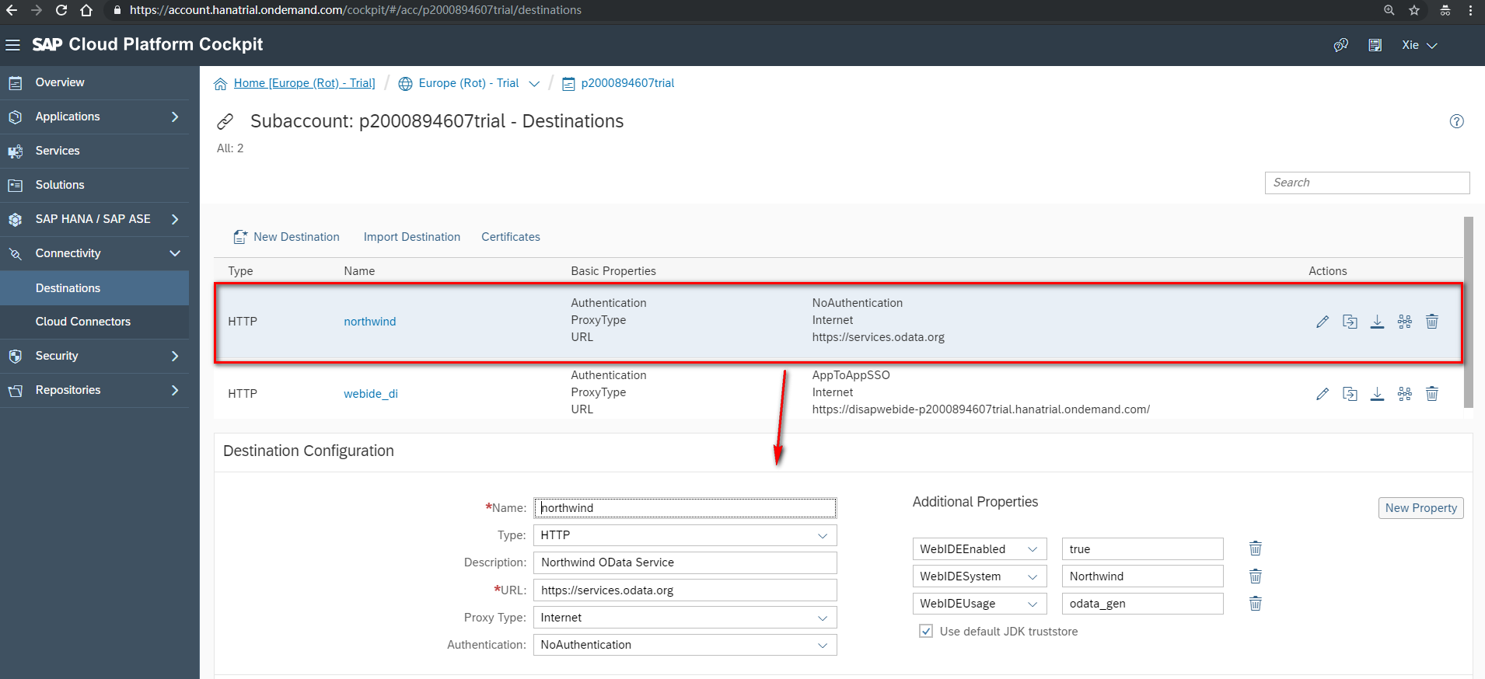

2.本地Mock-xml格式数据方法

2.1将destination文件下载至本地并移动至WebIDE对应的destination文件夹下

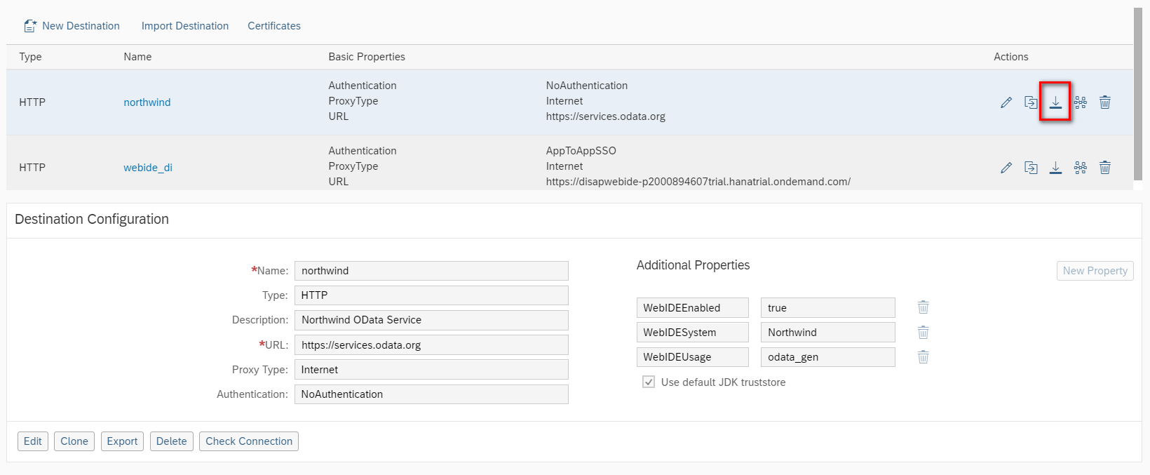

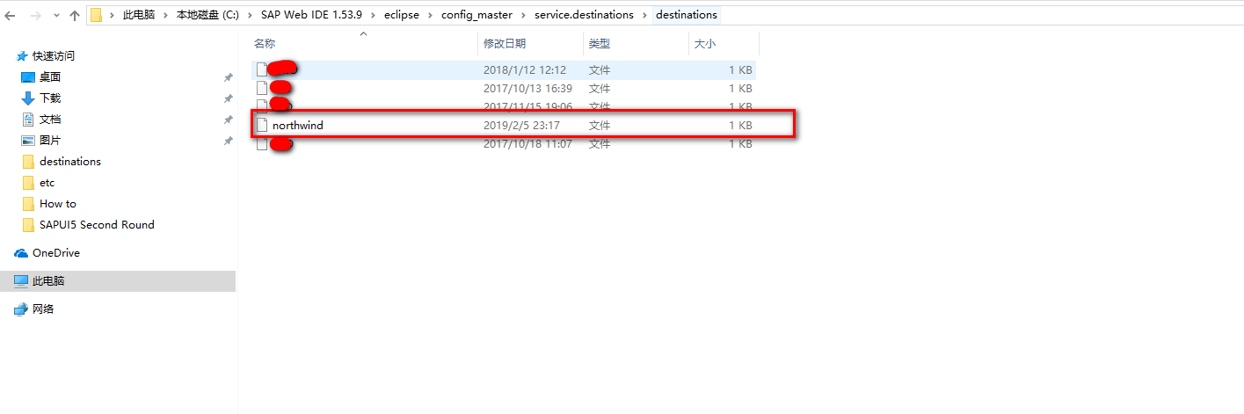

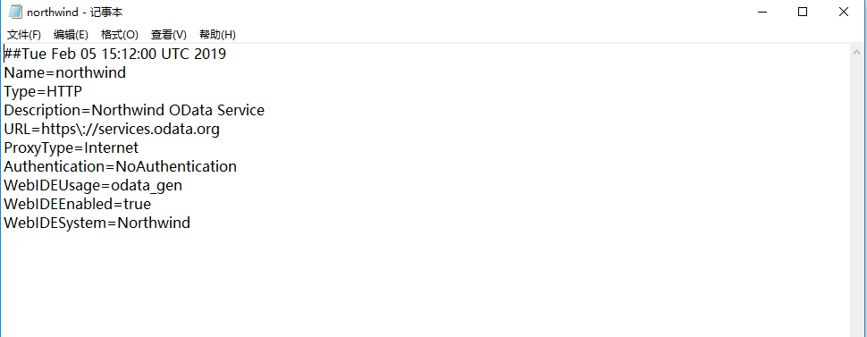

2.2 manifest.json添加服务

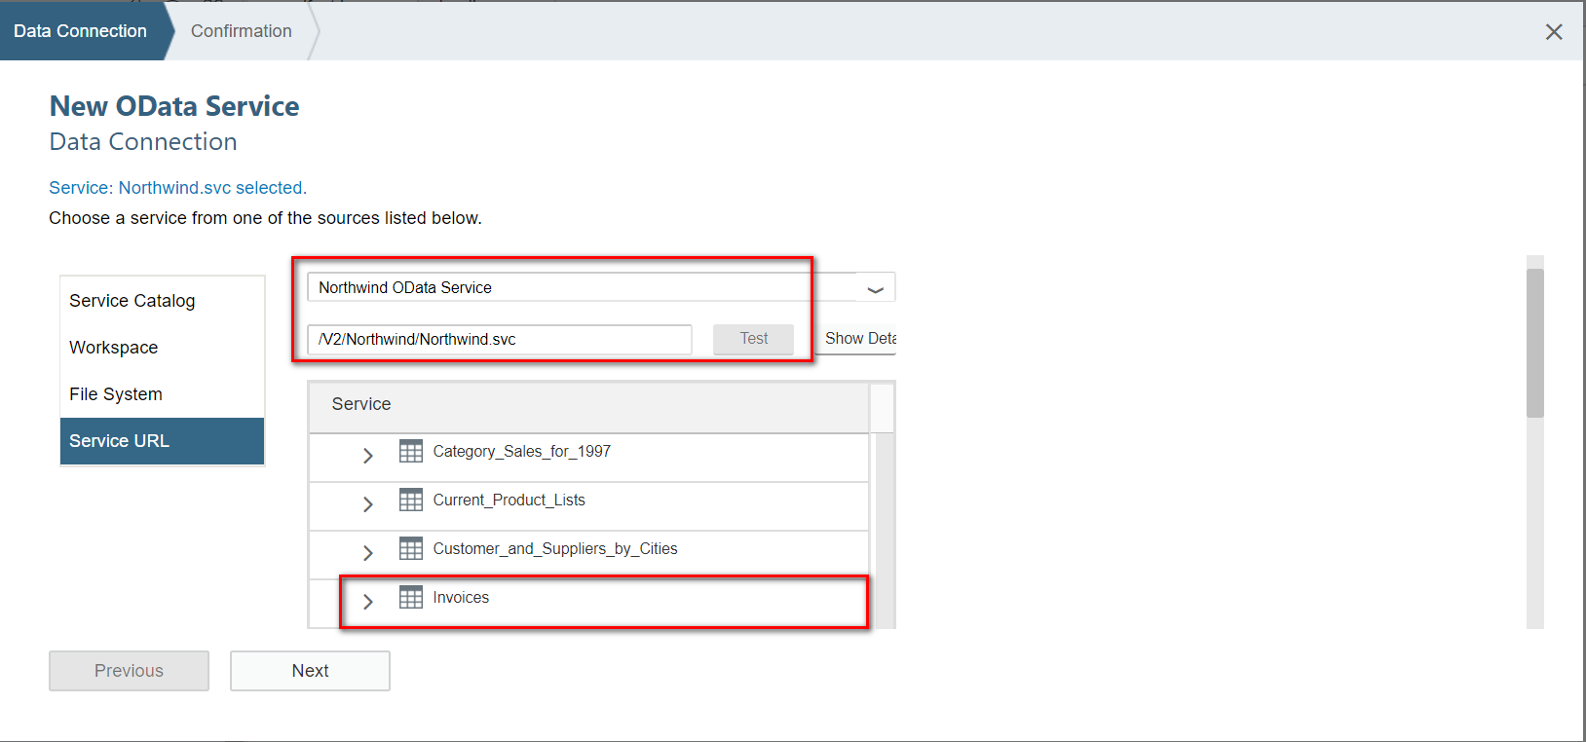

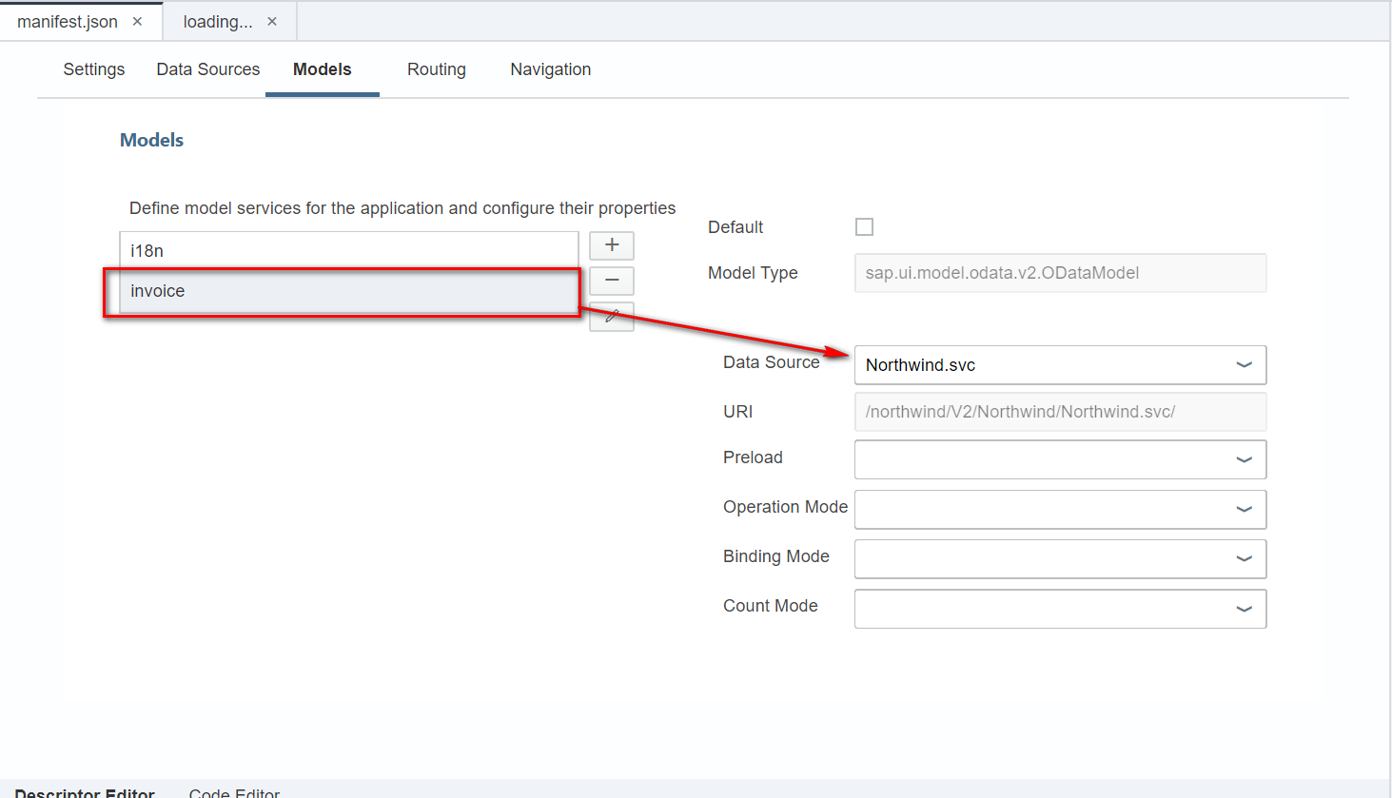

2.3 Mock-xml-data

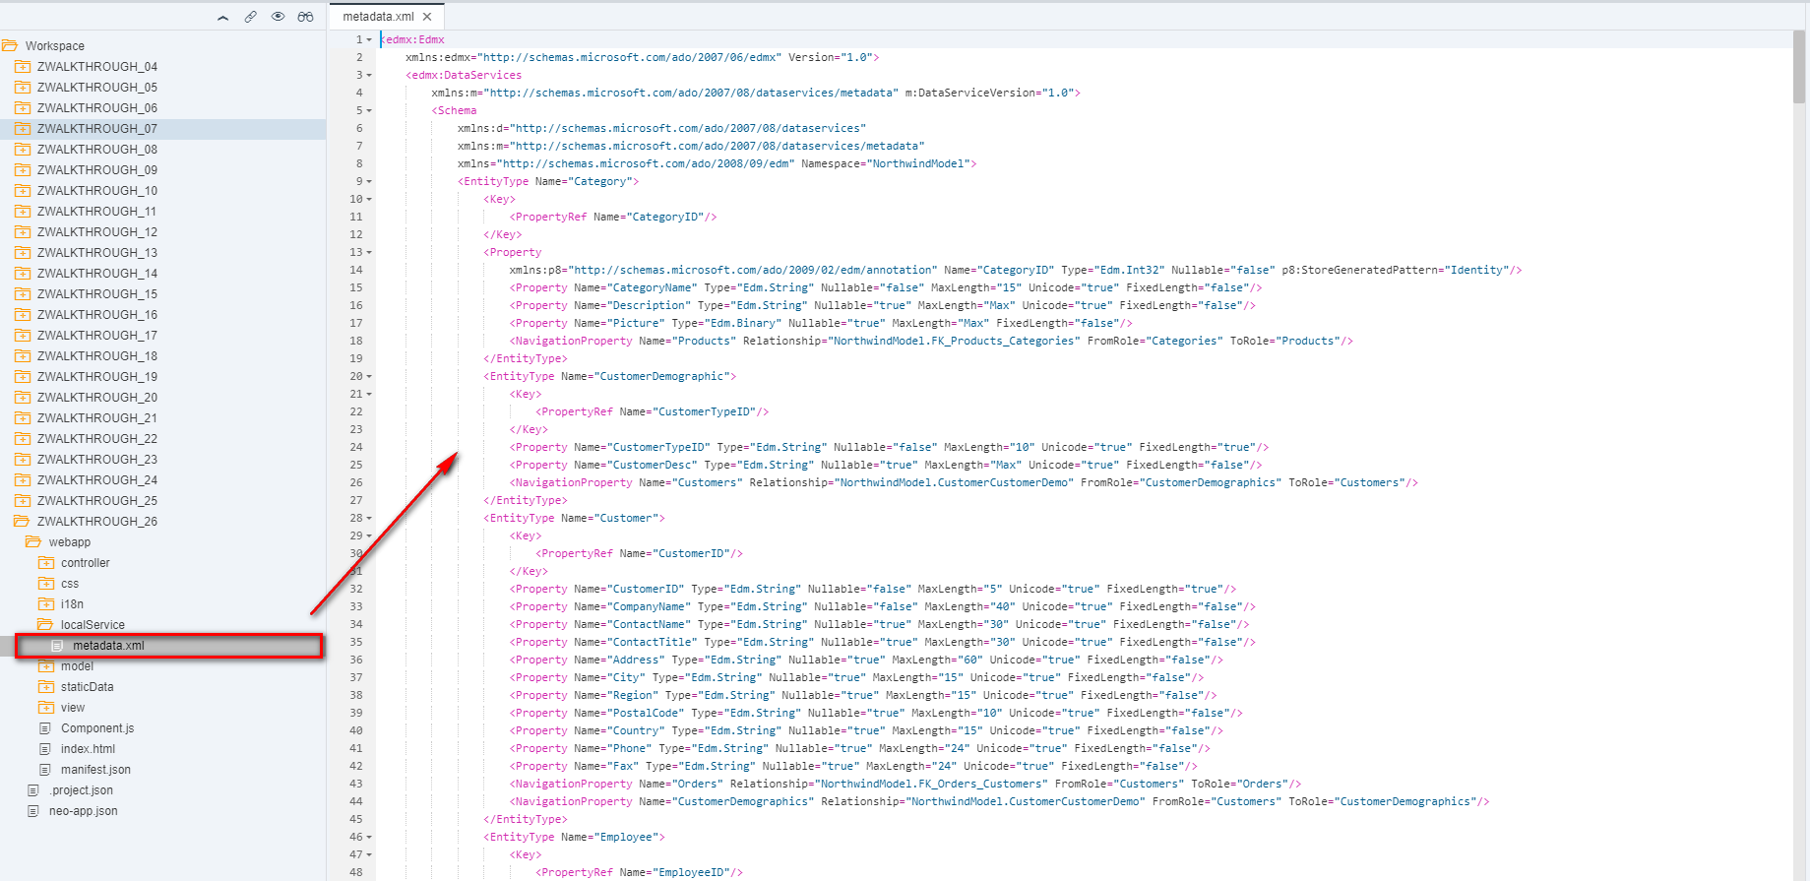

i18n 文本对象管理

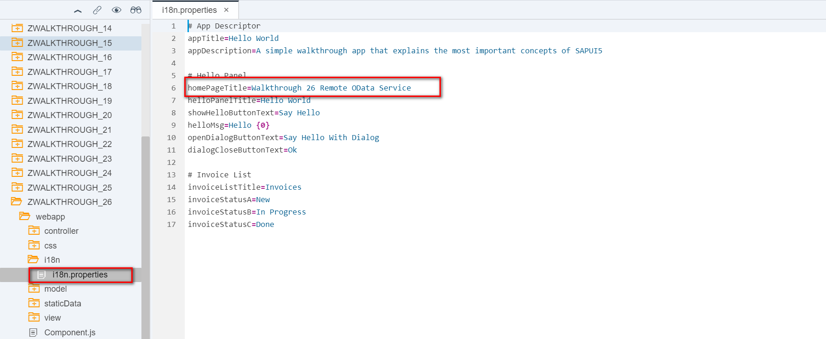

Result

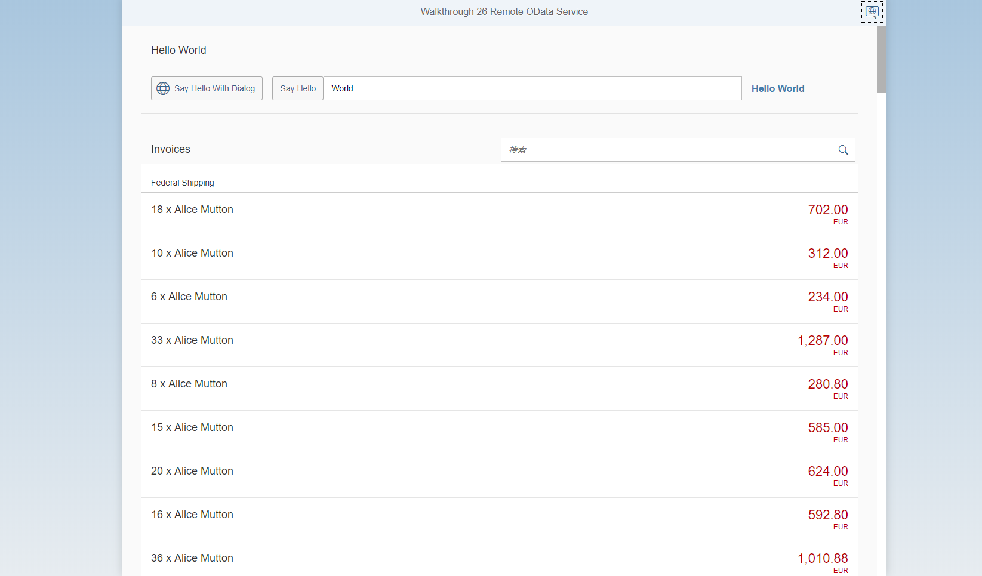

Git:

https://github.com/xiexiaop/SAPUI5-2-Round/tree/master/Projects/ZWALKTHROUGH_26

2019/02/05 XiaoMi Beijing Zac,Xie